Detection of Brute Force Login Attacks using Python Log Analysis
Author: Sakshi Singh
Date: March 2026

1. Introduction
Authentication systems are a critical part of cybersecurity. Attackers often attempt to gain unauthorized access by repeatedly trying different passwords. This method is known as a brute force attack.
Security teams monitor login logs to detect such suspicious activities. Repeated failed login attempts from the same IP address may indicate a brute force attack attempt.
This project demonstrates how login log data can be analyzed using Python to detect potential brute force attacks automatically.

2. Objective
The objective of this project is to develop a simple Python-based tool that analyzes login logs and identifies suspicious login behavior.
The tool detects IP addresses that generate multiple failed login attempts and flags them as potential brute force attack sources.

3. Tools Used
• Python Programming Language
• Text-based log files
• Command Prompt (Windows)
4. Methodology
The system reads a login log file containing IP addresses and login status (SUCCESS or FAILED).
The Python script processes each log entry and counts the number of failed login attempts for every IP address.

If the number of failed login attempts from an IP address exceeds a predefined threshold (3 attempts), the system generates an alert indicating a possible brute force attack.
5. Log File Example
192.168.1.10 FAILED
192.168.1.10 FAILED
192.168.1.10 FAILED
192.168.1.10 FAILED
192.168.1.10 FAILED
192.168.1.25 SUCCESS
192.168.1.30 FAILED
192.168.1.30 FAILED
192.168.1.30 FAILED
192.168.1.40 SUCCESS
6. Python script
from collections import defaultdict
log_file = "login_logs.txt"
failed_attempts = defaultdict(int)
with open(log_file, "r") as file:
for line in file:
ip, status = line.strip().split()
if status == "FAILED":
failed_attempts[ip] += 1
for ip, attempts in failed_attempts.items():
if attempts >= 3:
print(f"ALERT: Possible brute force attack from {ip}")
print(f"Failed login attempts: {attempts}\n")

7. Output
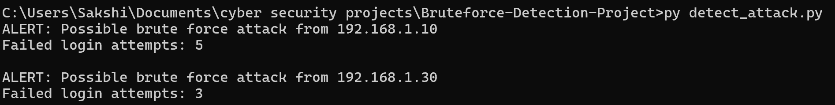
The above output was generated by executing the Python script in the Windows command prompt.
The system detected two IP addresses exceeding the failed login threshold and generated alerts.
These IP addresses were flagged as potential brute force attack sources.
8. Security Impact
Early detection of brute force attacks allows security teams to block malicious IP addresses before attackers gain unauthorized access.
Automated log analysis helps organizations monitor authentication systems efficiently and improves overall security posture
9. Conclusion:
This project demonstrates how Python can be used to automate security log analysis and detect potential brute force attacks.
Although this is a simplified implementation, the same concept is used in enterprise security monitoring systems to identify suspicious login activity and protect systems from unauthorized access.

